    Options Community Database System

    User Manual(Outline)

Table of Content

1. Introduction

2. Getting Started

* Requirements
* Installation

3. User Roles

* Admin
* Staff

4. Features

* Registration/Login
* Admin features
  + Creating a Center
  + Generating report
* Center Staff features
  + Creating a new family/participant
  + Creating a new Library Item
  + Creating an activity session
  + Signing a family into an activity session

Introduction

The Options Community Services Database System is designed to facilitate efficient and centralized recording of participants who attended the different activity sessions at the different branches of the Options Community Service Centres.

    Getting Started

**Requirements:**

* This application requires the following specifications for installation.
  + Windows Server 2008 R2
  + Microsoft SQL Server 2008

**Installation**

* … needs to be filled in.

Users

This application will be used by two different types of users : **Admin and Staff.**

* **Admin** **Accounts**: Has access to all functionalities and family records across all branches. One admin account is created by default.
* **Center Staff Accounts**: Has access to only family records only for his/her assigned branch. Center Staff Accounts must be created manually.

Features

1.1. Registration:

* To register for a new Staff account click on “Register”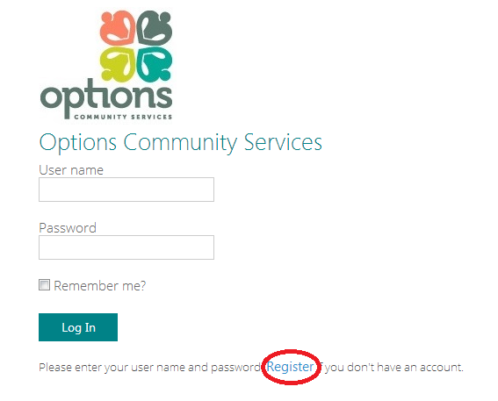
* Fill the required fields (Circled in red) and click Register

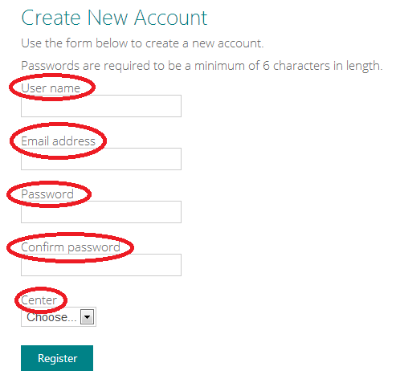

1.2. Logging in

* To Log in simply input your registration credentials.

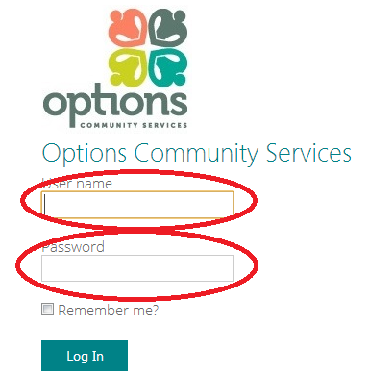

**Admin Features**

2.1 Creating a Center

* Admins can create new centers/branches. First log in with your admin credentials, then select the “Centers” tab.

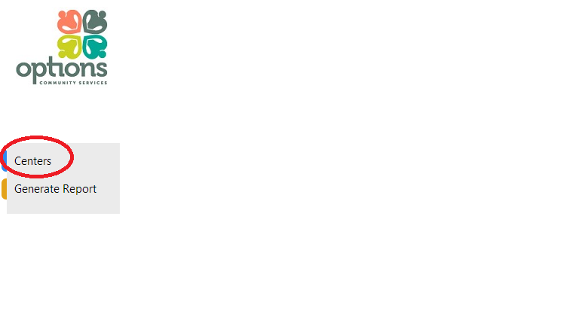

* The current table displayed shows all of the centers that have been created. Click on the “Create New” to add a new Center.

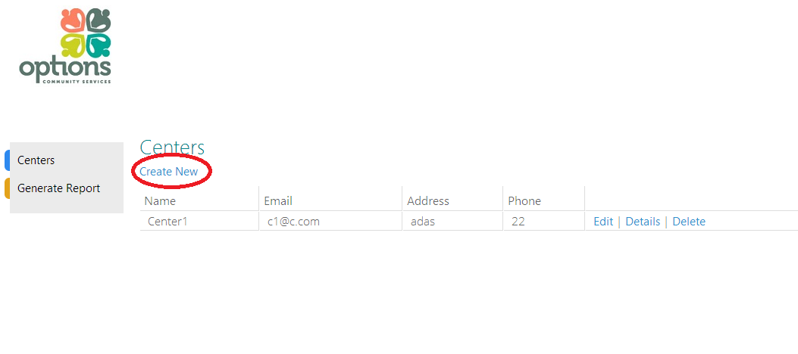

* Fill in the following fields and then click “Create” to add the new center.

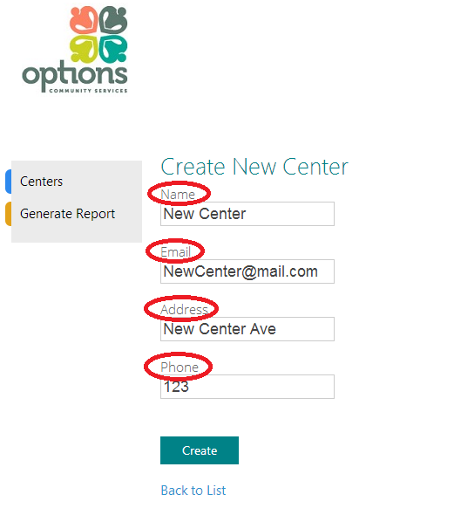

* You should be able to see the newly created center in the table now.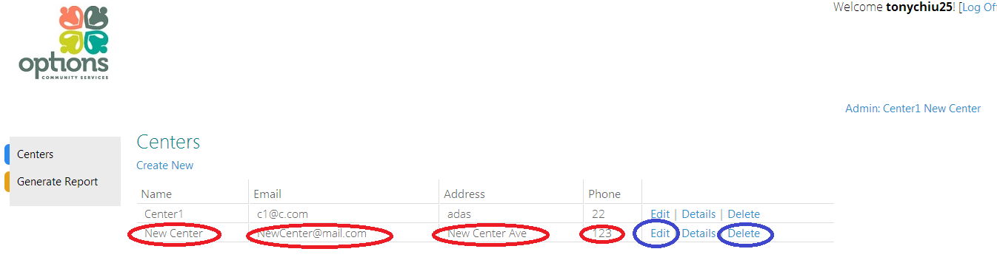
* To edit or delete the newly created center, click “edit” or “delete” button.

2.2 Generating Attendance Statistics Report.

* Attendance reports between two date ranges can be generated. Click on the Generate Report in the main admin tab.

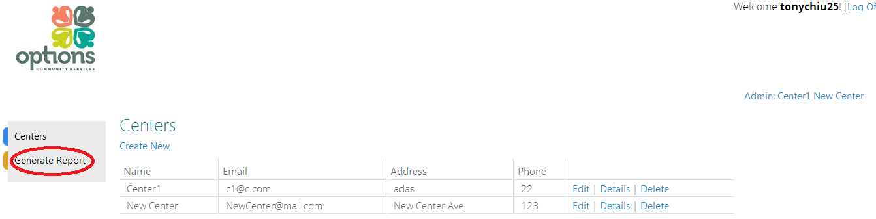

* Input a date range, start and end, and click on “Generate Report” to generate an attendance report base on those that date interval.

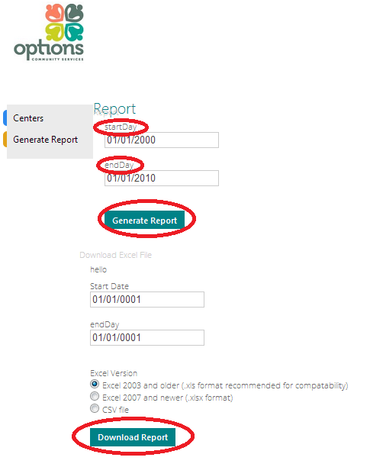

* Once generated, the report can be downloaded in excel or csv format by clicking on the “Download Report” Button.